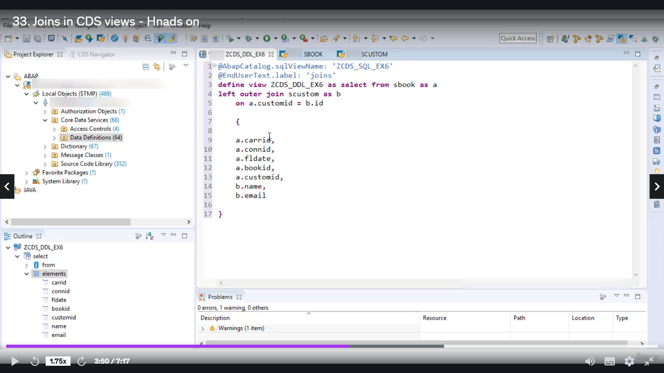

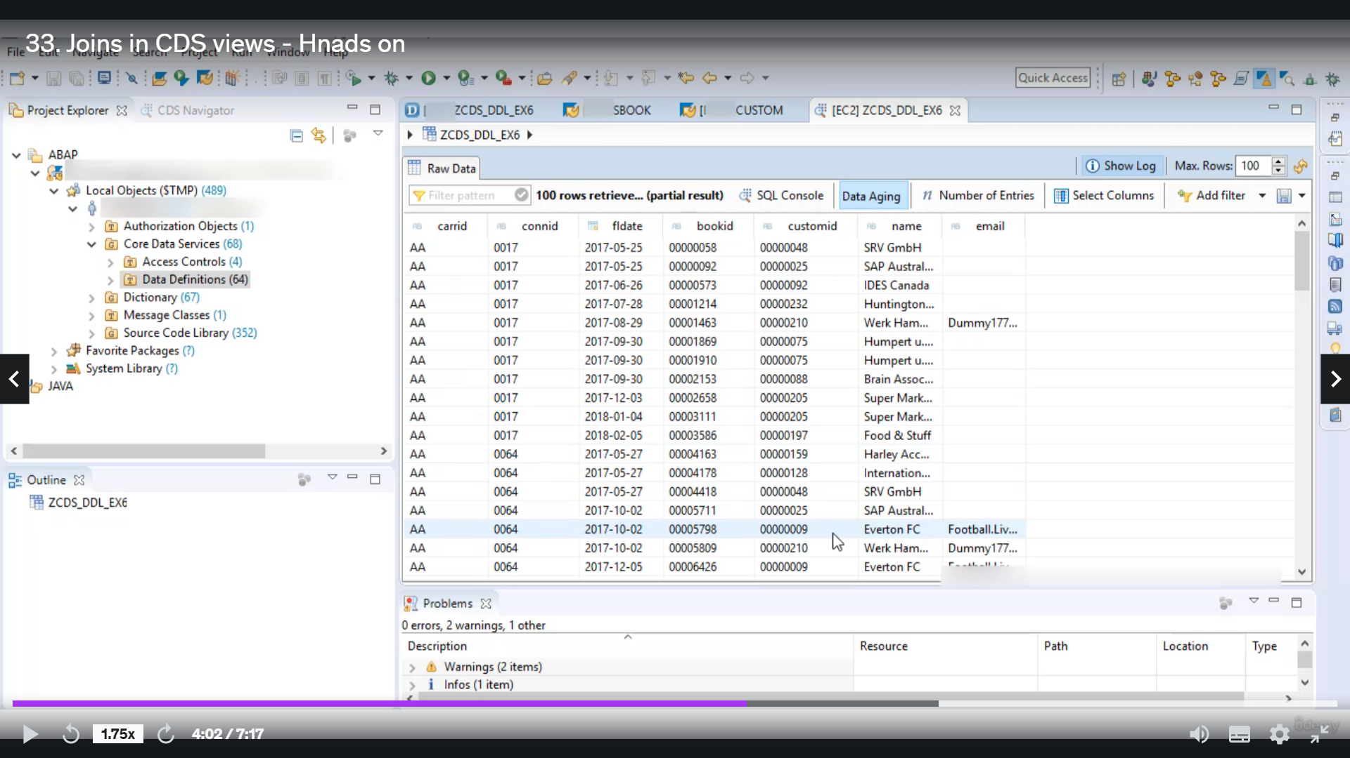

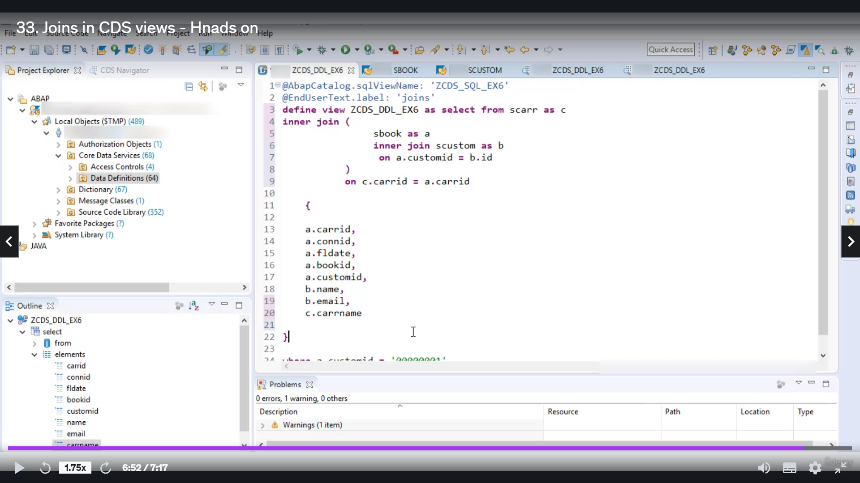

Let's quickly create whatever this will be in a joint.

I want to go in the studio to get serious, detailing simple things.

This is for joint.

OK, I know you have to use template and you with John.

So let's quickly first let a school name as serious as squill example six, I want to create this view

about this school where I want to join is bootable and.

It's custom table.

Britain joining condition.

Custom, Heidi.

So, yeah, it looked evil, it's related to flight booking, if you want to see what the fill in this

table, then you have to select the name and paste function of three.

So you are the first inaudible ASBA, similarly, if you want to see what the difference in the system

and again, this is through distributors, that customer related information for performing join, there

should be some common thread between these two tables.

And for that purpose, in joint condition, I will use food as customary in his book and I'd will from

that system.

OK, so in this example, we don't call this to an addition to it.

If you want to use it directly, you can use it or you can use Alia's to this debelin.

Suppose I want to refer to this book as A and its customers B C in that case, my joining condition

would be considered customary B dot Heidi.

OK, so now in this bracket we ought to specify the fields that you want to see in joint desert.

So let's say I want to use Carraro different from his book

idea again from his book, then flight date booking and then customary.

OK, so all these films are from people, as you know, we will take some pills from table as custom.

And that's it.

So we want to keep an absolutist view where we want to join to debates and book, and it's custom based

on joint condition and as output, we want all these fields and in the output, we want all these fields.

OK, so there is no error, you can activate it and.

Let's turn it to the city, the director of our joint.

By default, ambassadors who would join in their contents left out and join in place of laughter to

then you can use it to join us.

You also can use.

So let's say I want to use inner joint.

Within our joint to Federal Reserve, you can use Workload's.

I want to filter out the results of join based on customer loyalty, good customer I.D. one.

OK, so now let's quickly activate it and run.

And now here is the result.

Similarly, you can use backcloth having clothes and aggregation functions in a budget, ambassadors

with joint.

It is also possible to use Néstor joins in our studios.

Now let's see how you can do good for next year.

Join.

So I will add here when multiple.

This table contains Aadland related information.

So it's good, it's good to see.

He join.

So you have to take the second condition, you said just bracket.

OK, and now you have to read the joint condition on.

The common thread between people is, Karen is boogie's garatti, so I will use that C dot cariddi equals

e dot guarantee.

And suit the joining, the bracket will get first perform and then this joint will apply on the results

of this joint.

But let's add one for you from table etiquette, OK?

You don't need.

And that's it to now.

Let's quickly activate this one.

Andrew.

And here is the output, the Kaname is one of added and the results.

So this is all the joint work in.